|  |
| --- |
| **Name: VYSHNAV SURESH**  **Roll No: 56**  **Batch: B**  **Date: 4-04-2022** |

**NETWORKING & SYSTEM ADMINISTRATION LAB**

**Experiment No.: 2**

**Aim**

Hardware components

# Procedure

## 1. Graphics Processing Unit (GPU)

A graphics processing unit (GPU) is a specialized electronic circuit designed to rapidly manipulate and alter memory to accelerate the creation of images in a frame buffer intended for output to a display device. GPUs are used in embedded systems, mobile phones, personal computers, workstations, and game consoles.

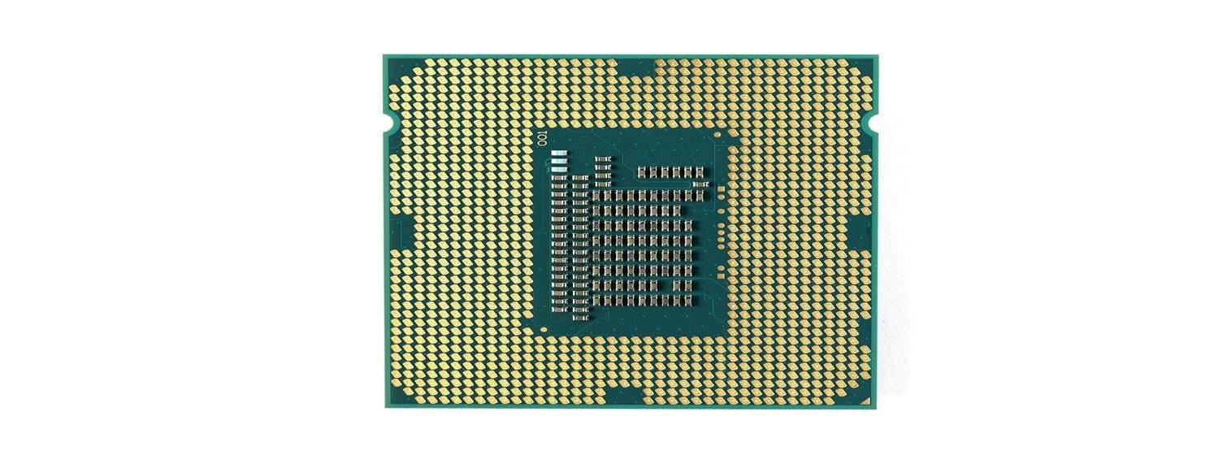

## 2. Hard drive

A hard disk drive (HDD) is composed of a platter that contains compartments to hold data. This data is your operating system, applications, and any files you have created. There is also an accuator arm that moves across the platter to read or write the information requested. To make this process faster, the platter spins as the accuator arm moves across it.

There are two different types of storage devices: the traditional hard disk drive (HDD) and the newer solid state drives (SSD). Hard disk drives work by writing binary data onto spinning magnetic disks called platters that rotate at high speeds, while a solid-state drive stores data by using static flash memory chips.

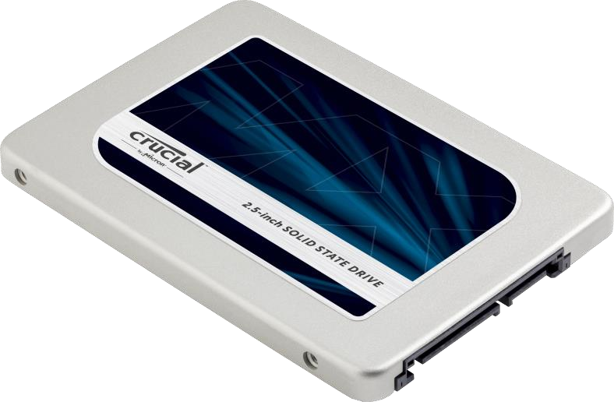

## 3. CPU (Central Processing/Processor Unit)

A Central Processing Unit is also called a processor, central processor, or microprocessor. It carries out all the important functions of a computer. It receives instructions from both the hardware and active software and produces output accordingly. It stores all important programs like operating systems and application software. CPU also helps Input and output devices to communicate with each other. Owing to these features of CPU, it is often referred to as the brain of the computer.

CPU is installed or inserted into a CPU socket located on the motherboard. Furthermore, it is provided with a heat sink to absorb and dissipate heat to keep the CPU cool and functioning smoothly.

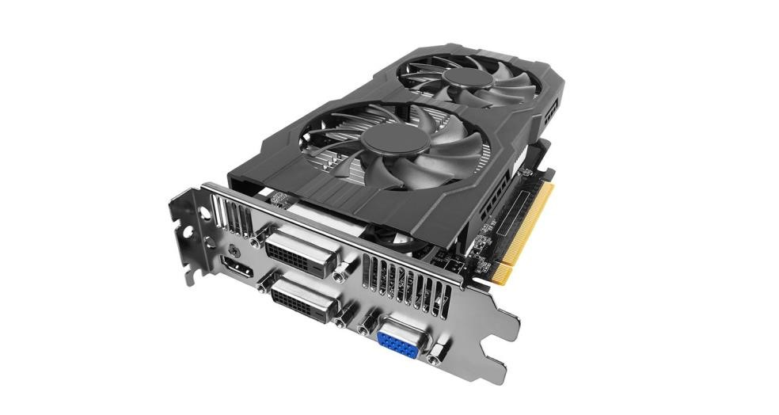

## 4. Monitor or Visual Display Unit (VDU)

Stands for "Visual Display Unit." A VDU displays images generated by a computer or other electronic device. The term VDU is often used synonymously with "monitor," but it can also refer to another type of display, such as a digital projector. Visual display units may be peripheral devices or may be integrated with the other components. For example, the Apple iMac uses an all-in-one design, in which the screen and computer are built into a single unit.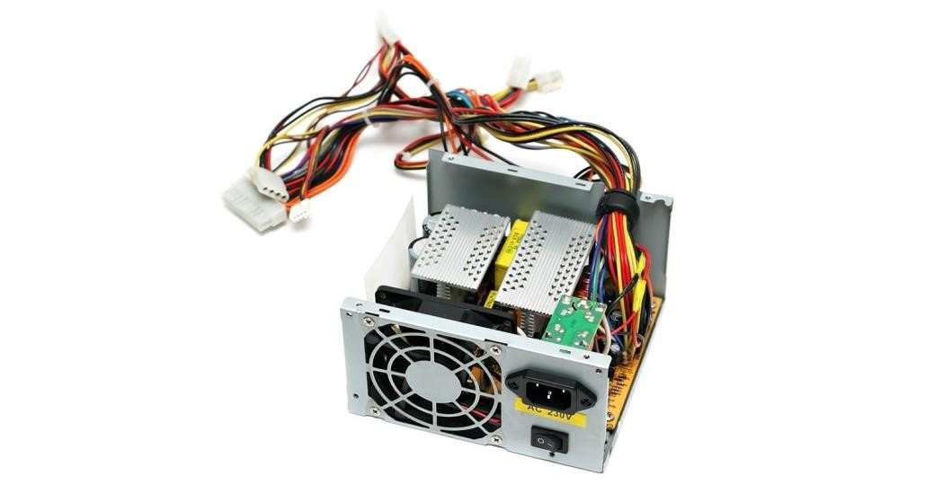

### 5. Power Supply Unit (PSU)

A Power Supply Unit (PSU) is an internal IT hardware component. Despite the name, Power Supply Units (PSU) do not supply systems with power - instead they convert it. Specifically, a power supply converts the alternating high voltage current (AC) into direct current (DC), and they also regulate the DC output voltage to the fine tolerances required for modern computing components.

Most power supplies are switched-mode (SMPS), which has both efficiency advantages and makes designing for multiple voltage inputs easier. This means that most PSUs can operate in different countries where the power input might change. In the UK, the voltage is 240V 50Hz, whereas in the USA the voltage is 120V 60Hz, and in Australia it is 230V 50Hz.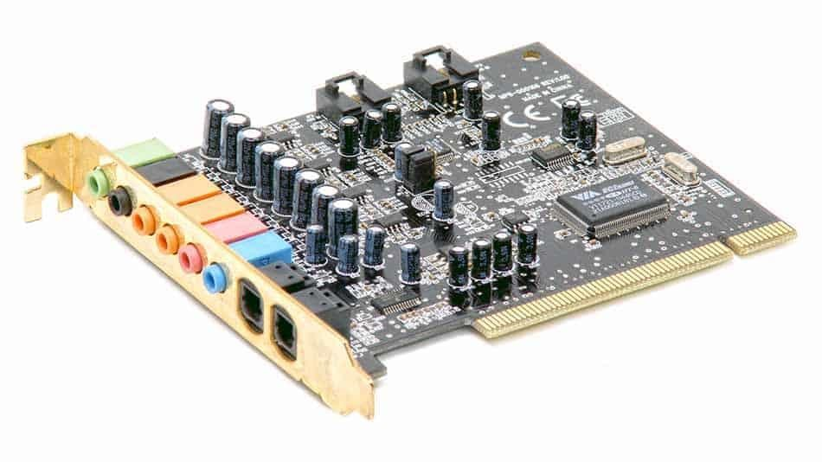

### 6. SSD: Solid State Drive

An SSD, or solid-state drive, is a type of storage device used in computers. This non-volatile storage media stores persistent data on solid-state flash memory. SSDs replace traditional hard disk drives (HDDs) in computers and perform the same basic functions as a hard drive. But SSDs are significantly faster in comparison. With an SSD, the device's operating system will boot up more rapidly, programs will load quicker and files can be saved faster. 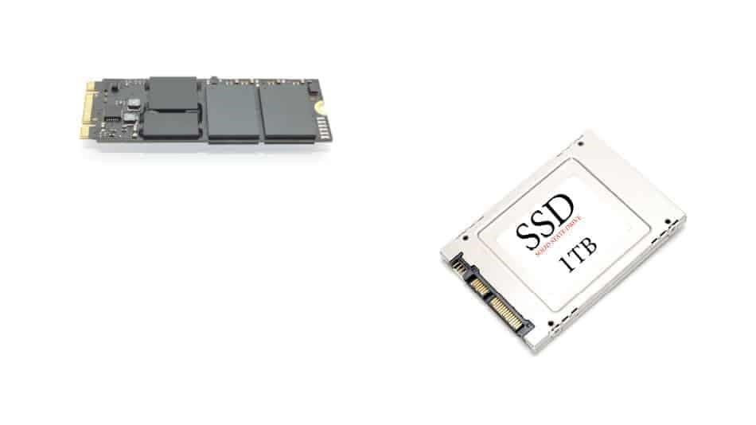

### 7. Sound Card

A sound card is an expansion component used in computers to receive and send audio. Sound cards are configured and utilized with the help of a software application and a device driver. The input device attached to receive audio data is usually a microphone, while the device used to output audio data is generally speakers or headphones.

The sound card converts incoming digital audio data into analog audio so that the speakers can play it. In the reverse case, the sound card can convert analog audio data from the microphone into digital data that can be stored on the computer and altered using audio software.

Sound cards are also known as audio adapters.

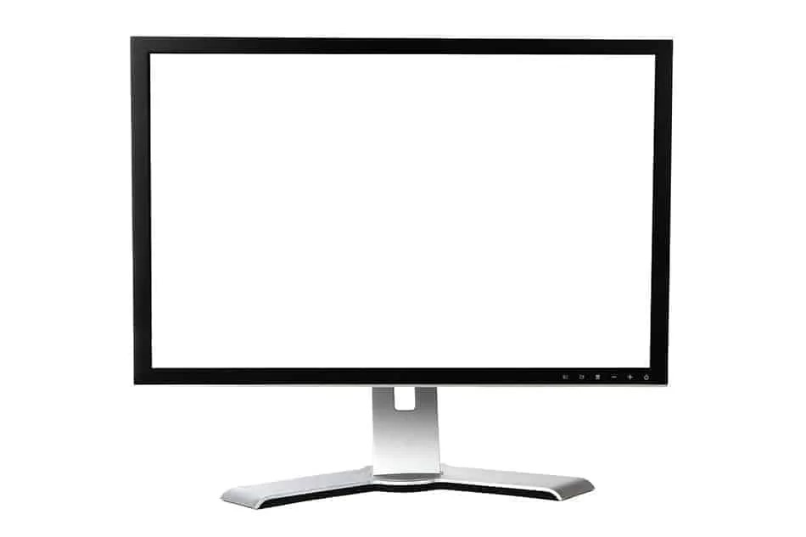

### 8. Printers

A printer is an external hardware output device that takes the electronic data stored on a computer or other device and generates a hard copy. For example, if you created a report on your computer, you could print several copies to hand out at a staff meeting. Printers are one of the most popular computer peripherals and are commonly used to print text and photos. The picture is an example of an inkjet computer printer, the Lexmark Z605.

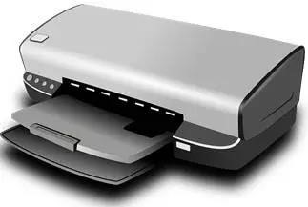

### 9. Scanner

A scanner is an electrical device that reads and converts documents such as photos and pages of text into a digital signal. This changes the documents in a form that can be viewed and or modified on a computer system by using software applications. There are numerous kinds of scanners available in the market that have different resolutions.

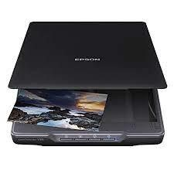

### 10. Optical Disc Drive

Optical drives retrieve and/or store data on optical discs like CDs, DVDs, and BDs (Blu-ray discs), any of which hold much more information than previously available portable media options like the floppy disk.

The optical drive normally goes by other names like a disc drive, ​ODD (abbreviation), CD drive, DVD drive, or BD drive.

Some popular optical disc drive makers include LG, ASUS, Memorex, and NEC. In fact, one of these companies probably manufactured your computer or other device's optical drive, even though you never see their name anywhere on the drive itself.

